**BRIGHT WAY INTER COLLEGE**



**ACADEMIC YEAR: 2020-21**

**PROJECT REPORT ON**

E9

**CREATING MOVIE TICKET BOOKING MANAGEMENT SYSTEM**

**NAME : AYUSH VERMA**

**ROLL NO :**

**CLASS : XII SEC : PCM**

**SUBJECT : COMPUTER SCIENCE**

**SUB CODE : 083**

**UNDER THE GUIDANCE OF**

**Mr. EHTESHAM TAHIR**

**TEACHER’S SIGN**

# **PROFILE**

Student’ s Name : AYUSH VERMA

Roll No :

Class : XII Sec : PCM

Course title : Movie Ticket Management

Institute’ s Name : Bright Way Inter College

Project Topic : Movie Ticket Management system

Language Used : Python with MySQL

Project Guide : Mr. Ehtesham Tahir

Designation : PGT Computer Science

# CERTIFICATE

This is to certify that Cadet **AYUSH VERMA** Roll No: has successfully completed the project Work entitled MOVIE TICKET MANAGEMENT SYSTEM the subject Computer Science (083) laid down in the regulations of CBSE for the purpose of Practical Examination in Class XII to be held in **BRIGHT WAY INTER COLLEGE** on______________.

**(**Mr. EHTISHAM TAHIR**)**

PGT Comp Science

***Master IC***

**Examiner Sign:**

**DECLARATION**

I **(AYUSH VERMA)** student of Intermediate CBSE Board

Year 2020-2021 from **Bright Way Inter College , Lucknow**

Declare that this project is our original work and it has not previously formed the basis of award of any certificate or similar other title.

AYUSH VERMA

Roll No. :

College : Bright Way College, Lucknow

**Preface**

This project is made for the partial fulfillment of the Intermediate course.

**Movie Ticket Management System** project objective is to book cinema tickets in online. The Movie Ticket Management System is an Internet based application that can be accessed throughout the Net and can be accessed by anyone who has a net connection. This application will reserve the tickets. This online ticket reservation system provides an interface for a cinema hall where any user of internet can access it. User is required to login to the system.

But all this excitement vanishes after standing in hours in long queues to get tickets booked. The website provides complete information regarding currently running movies on all the screens with details of show timings. Ticket reservations are done using credit card and can be cancelled if needed. Our online tickets reservation system is one of the best opportunities for those who cannot afford enough time to get their tickets reserved standing in long queues. People can book tickets online at any time of day or night. Our reservation system also provides option to cancel the tickets which are reserved previously.

|  |  |  |
| --- | --- | --- |
| **TABLE OF CONTENTS** | | |
| **S.NO.** | **DESCRIPTION** | **PAGE NO** |
| 01 | INTRODUCTION | **08** |
| 02 | OBJECTIVES OF THE PROJECT | **09** |
| 03 | HARDWARE AND SOFTWARE REQUIREMENTS | **10** |
| 04 | FEATURES OF MOVIE TICKET MANAGEMENT SYSTEM | **11** |
| 05 | USER DOCUMENT | **12** |
| 06 | FUNCTIONS USED | **13** |
| 06 | SOURCE CODE | **15** |
| 07 | OUTPUTS | **23** |
| 08 | BIBLIOGRAPHY | **27** |

**ACKNOWLEDGEMENT**

Apart from the efforts of me, the success of any project depends largely on the encouragement and guidelines of many others. I take this opportunity to express my gratitude to the people who have been instrumental in the successful completion of this project.

I express deep sense of gratitude to almighty God for giving me strength for the successful completion of the project.

I express my heartfelt gratitude to my parents for constant encouragement while carrying out this project.

I gratefully acknowledge the contribution of the individuals who contributed in bringing this project up to this level, who continues to look after me despite my flaws.

I express my deep sense of gratitude to the luminary The Principal, BRIGHT WAY INTER COLLEGE who has been continuously motivating and extending their helping hand to us.

I express my sincere thanks to the academician The Vice Principal, BRIGHT WAY INTER COLLEGE, for constant encouragement and the guidance provided during this project

I am overwhelmed to express my thanks to The Administrative Officer for providing me an infrastructure and moral support while carrying out this project in the school.

My sincere thanks to. **Mr. EHTESHAM TAHIR**, Master In-charge, A guide, Mentor all the above a friend who critically reviewed my project and helped in solving each and every problem, occurred during implementation of the project

The guidance and support received from all the members who contributed and who are contributing to this project, was vital for the success of the project. I am grateful for their constant support and help.

**PROJECT ON CREATING MOVIE TICKET BOOKING SYSTEM (MTBS)**

**INTRODUCTION**

The "Movie Ticket Booking System" has been developed to override the problems

prevailing in the practicing manual system. This software is supported to eliminate and in some cases reduce the hardship faced by this existing system. Moreover this

system is designed for the particular need of the company to carry out operations in a smooth and effective manner.

The application is reduced as much as possible to avoid errors while entering the data. It also provides error message while entering invalid data. No formal knowledge is needed for the user to use this system. Thus by this al it proves itis user-friendly. Movie Ticket Booking System, as described above, can lead to error free, secure, relatable and fast management system. It can assist the user to concentrate on their other activities rather to concentrate on the record keeping. Thus it will help organization in better utilization of resources.

Every organization, whether big or small, has challenges to overcome and managing

the information of Customer, Movie, Payment, Shows, Seats. Every Movie Ticket

Booking System has different Movie needs, therefore we design exclusive employee

management systems that are adapted to your managerial requirements. This is

designed to assist in strategic planning, and will help you ensure that your organization is equipped with the right level of information and details for your future goals. Also, for those busy executive who are always on the go, our systems come with remote access features, which will allow you to manage your workforce anytime, at all times. These systems will ultimately allow you to better manage resources.

**OBJECTIVES OF THE PROJECT**

The main objective of the Movie Ticket Booking System is to manage the details of Seats, Booking, Customer, Payment, Shows. It manages all the information about Seats, Movie, Shows, Seats. The project is totally built at administrative end and thus only the administrator is guaranteed the access. The purpose of the project is to build an application program to reduce the manual work for managing the Seats, Booking, Movie, Customer. It tracks all the details about the Customer, Payment, Shows.

**HARDWARE AND SOFTWARE REQUIREMENTS**

**Hardware Requiremants :**

**Processor :** Intel Pentium Processor III

**Speed :** 700 MHz

**RAM :** 128 MB

**Free HDD Space :** 10 GB

**Mouse :** 3 button scroll mouse

**Keyboard :** 104 keys keyboard

**Monitor :** 15” colour

**Software Requirements:**

**Front End :** Python

**Back End :** MySQL

**Operating System :** Microsoft Windows 7

**FEATURES OF MOVIE TICKET MANAGEMENT SYSTEM**

* Provides the searching facilities based on various factors. Such as Seats, Customer, Payment, Shows
* The transactions are executed in off-line mode, hence on-line data for Seats, Booking capture and modification is not possible.
* It tracks all the information of Booking, Movie, Payment etc.
* Manage the information of Booking
* Shows the information and description of the Seats, Customer
* All the fields such as Seats, Customer, Shows are validated and does not take invalid values
* It generates the receipt on Seats, Booking, Movie
* To increase efficiency of managing the Seats, Booking
* It deals with monitoring the information and transactions of Payment.
* Manage the information of Payment.
* Integration of all records of Shows.

**USER DOCUMENT**

* **BOX OFFICE -** This will give user a table that shows all the movies of box office which are current present in theater with their prices and showtime and with other details.
* **SHOW MOVIE RATING/REVIEW -** This will take user to the site where he/she can see his/her movie review and ratings.
* **BOOKING COUNTER -** This will show user a table of movies with their prices and a unique Movie code , user will ask for movie code of movie which he or she want to book, after giving code ,it will take some information of you and how many tickets you want and book your tickets.
* **SHOW BOOKING DETAILS** **-** This will show user a table of how many tickets of movies he bought with other details.
* **CANCELLATION -** This will help user to cancel his ticket which he

book previously in our theater.

* **RECEIPT BILL** **-** This will give user a table of receipt of with his or her total payable amount.
* **EXIT –** This will enable the user to exit from movie ticket management system.

**FUNCTIONS USED**

This project on movie ticket management system is very user interactive. The way of handling this project is very When a user runs the project a welcome screen will be there. Then on pressing any key he will turn to the main menu and then there will be certain options like the following. The procedure to use all the options is listed below

* **cursor() :- Cursor** class is an instance using which you can invoke methods that execute SQLite statements, fetch data from the result sets of the queries. You can create **Cursor** object using the **cursor()** method of the Connection object/class.
* **execute() :-** This function is used for the dynamic execution of Python program which can either be a string or object code. If it is a string, the string is parsed as a suite of Python statements which is then **executed** unless a syntax error occurs and if it is an object code, it is simply **executed**.
* **Input() :- This**function to take input from the user. Whatever you enter as input, the input function converts it into a string. If you enter an integer value still **input()** function convert it into a string.
* **print() :-** This function **prints** the specified message to the screen, or other standard output device. The message can be a string, or any other object, the object will be converted into a string before written to the screen.
* **is_connected()** :- is the MYSQL function to verify whether the python application is connected to mysql database
* **fetchall()** :- This function fetches all the rows of a query result. It returns all the rows as a list of tuples. An empty list is returned if there is no record to fetch.
* **tabulate()** :- It is an open-source python package/module which is used to print tabular data in nicely formatted tables. It is easy to use and contains a variety of formatting functions.
* **webbrowser.open()** :- Python has a module called webbrowser, which allows to open the web browser from a python script by simply calling the **open()** function of the module. The webbrowser.open() method will open your default web browser with a given url.
* **Commit()** :- This method sends a COMMIT statement to the MySQL server, committing the current transaction. Since by default Connector/Python does not auto commit, it is important to call this method after every transaction that modifies data for tables that use transactional storage engines.
* **connect() :-** The **connect()** method of Python's socket module, connects a TCP(Transmission Control Protocol) based client socket to a TCP based server socket.

**SOURCE CODE**

to create database.py

#program to create mysql database movie_ticket

import mysql.connector as sql

conn=sql.connect(host = 'localhost',port='3306',user='root',passwd='bwc')

mycursor=conn.cursor()

mycursor.execute('DROP DATABASE IF EXISTS movie_tickets')

mycursor.execute('CREATE DATABASE movie_tickets')

mycursor.execute('USE movie_tickets')

mycursor.execute('DROP TABLE IF EXISTS theater')

sql = '''CREATE TABLE theater(MOVIES CHAR(20) NOT NULL,

PHONE_NO INT NOT NULL,

TICKET INT NOT NULL,SEX CHAR(20) NOT NULL,

FIRST_NAME CHAR(20) NOT NULL,LAST_NAME CHAR(20) NOT NULL,SNACKS CHAR(20) NOT NULL)'''

mycursor.execute(sql)

mycursor.execute('USE movie_tickets')

sql2= '''CREATE TABLE name(S_No int NOT NULL,MOVIES CHAR(20) NOT NULL,

SHOW_TIME CHAR(20) NOT NULL,

DATE char(20) NOT NULL,PRICE int NOT NULL,GRNRE char(20) NOT NULL)'''

mycursor.execute(sql2)

mycursor=conn.cursor()

mycursor.execute('USE movie_tickets')

#M1

sql3A='''INSERT INTO name values(1001,'Alladin','9am-12noon','20-march-2021',250,'Fantacy\\Family')'''

mycursor.execute(sql3A)

#M2

sql4A='''INSERT INTO name values(1002,'Insepion','12non-3pm','20-march-2021',150,'Sci-Fi')'''

mycursor.execute(sql4A)

#M3

sql5A='''INSERT INTO name values(1003,'Kgf2','3pm-6pm','20-march-2021',200,'Action\\Drama')'''

mycursor.execute(sql5A)

#M4

sql6A='''INSERT INTO name values(1004,'War','6pm-9pm','20-march-2021',150,'Action')'''

mycursor.execute(sql6A)

#M5

sql7A='''INSERT INTO name values(1005,'A Walk To Remember','9pm-12pm','20-march-2021',350,'Romantic')'''

mycursor.execute(sql7A)

mycursor=conn.cursor()

conn.commit()

movie ticket management system.py

import mysql.connector as sql

from tabulate import tabulate

import webbrowser

conn=sql.connect(host = 'localhost',port='3306',user='root',passwd='bwc')

mycursor=conn.cursor()

mycursor.execute('USE movie_tickets')

print ("LOG IN")

Enter_user=input("Enter userID :")

Enter_passwd=input("Enter password :")

if Enter_user=='asa' and Enter_passwd=='asa':

print('')

print('')

print (" _ _ _ _ _ _ _ _ _ _ _ _WELCOME BACK_ _ _ _ _ _ _ _ _ _ _ _")

if conn.is_connected():

print('')

print('')

print('')

print ("|$|$$$$$$$$$$$$ ASA THEATRE BOOKING (AC & NON AC) $$$$$$$$$$$$|$|")

print ("|$| |$|")

print ("|$| |$|")

print ("|$|_*_*_*_*_*_*_*_*_*_*_*_*_*_*_*_*_*_*_*_*_*_*_*_*_*_*_*_|$|")

print ("|$| |$|")

print ("|$|~~~~~~~~~~~~~~~~~~~ASA THEATRES~~~~~~~~~~~~~~~~~~~~~~~~|$|")

print ("|$| |$|")

print ("|$| 1. BOX OFFICE |$|")

print ("|$| 2. SHOW MOVIE RATING/REVIEW |$|")

print ("|$| 3. BOOKING COUNTER |$|")

print ("|$| 4. SHOW BOOKING DETAILS |$|")

print ("|$| 5. CANCELLATION |$|")

print ("|$| 6. RECEIPT BILL |$|")

print ("|$| 7. EXIT |$|")

print ("|$|_-_-_-_-_-_-_-_-_-_-_-_-_-_-_-_-_-_-_-_-_-_-_-_-_-_-_-_-_-_-_-_-_-_-_-_-_|$|")

ch=int(input("Enter your choice :"))

while True:

if ch==1:

mycursor.execute("select * from name")

data1=mycursor.fetchall()

print(tabulate(data1,headers=['MOVIES','SHOW_TIME','DATE','PRICE','GENRE'], tablefmt='psql'))

print ("+~~~~~~~~~~ASA THEATRES~~~~~~~~~~~+")

print ("| |")

print ("| 1. BOX OFFICE |")

print ("| 2. SHOW MOVIE RATING/REVIEW |")

print ("| 3. BOOKING COUNTER |")

print ("| 4. SHOW BOOKING DETAILS |")

print ("| 5. CANCELLATION |")

print ("| 6. RECEIPT BILL |")

print ("| 7. EXIT |")

print ("|_-_-_-_-_-_-_-_-_-_-_-_-_-_-_-_-_-_-_-_-_-_-|")

ch=int(input("Enter your choice :"))

elif ch==2:

webbrowser.open('https://www.imdb.com/',new=1)

break

print (" ")

print (" ")

print ("+~~~~~~~~~~ASA THEATRES~~~~~~~~~~~+")

print ("| |")

print ("| 1. BOX OFFICE |")

print ("| 2. SHOW MOVIE RATING/REVIEW |")

print ("| 3. BOOKING COUNTER |")

print ("| 4. SHOW BOOKING DETAILS |")

print ("| 5. CANCELLATION |")

print ("| 6. RECEIPT BILL |")

print ("| 7. EXIT |")

print ("|_-_-_-_-_-_-_-_-_-_-_-_-_-_-_-_-_-_-_-_-_-_-|")

ch=int(input("Enter your choice :"))

elif ch==3:

mycursor.execute("select S_No, MOVIES, PRICE from name;")

data1=mycursor.fetchall()

print(tabulate(data1,headers=['MOVIE CODE','MOVIES','PRICE'], tablefmt='psql'))

ch=int(input("Select the movie code :"))

if ch==1001:

MOVIES = ("Alladin")

print ("Alladin selected")

PHONE_NO = input("Enter phone number :")

TICKET = input("Enter total tickets :" )

SEX = input ("Enter your sex :" )

FIRST_NAME = input ("Enter your first name :")

LAST_NAME = input ("Enter your last name :")

SNACKS = input ("Order your snacks :")

ins="insert into theater values( '{}','{}','{}','{}','{}','{}','{}')".format (MOVIES,PHONE_NO,TICKET,SEX,

FIRST_NAME,LAST_NAME,SNACKS)

mycursor.execute(ins)

conn.commit()

elif ch==1002:

MOVIES = ("Insepion")

print ("Insepion selected")

PHONE_NO = input("Enter phone number :")

TICKET = input("Enter total tickets :" )

SEX = input ("Enter your sex :" )

FIRST_NAME = input ("Enter your first name :")

LAST_NAME = input ("Enter your last name :")

SNACKS = input ("Order your snacks :")

ins="insert into theater values( '{}','{}','{}','{}','{}','{}','{}')".format (MOVIES,PHONE_NO,TICKET,SEX,

FIRST_NAME,LAST_NAME,SNACKS)

mycursor.execute(ins)

conn.commit()

elif ch==1003:

MOVIES = ("Kgf2")

print ("Kgf2 selected")

PHONE_NO = input("Enter phone number :")

TICKET = input("Enter total tickets :" )

SEX = input ("Enter your sex :" )

FIRST_NAME = input ("Enter your first name :")

LAST_NAME = input ("Enter your last name :")

SNACKS = input ("Order your snacks :")

ins="insert into theater values( '{}','{}','{}','{}','{}','{}','{}')".format (MOVIES,PHONE_NO,TICKET,SEX,

FIRST_NAME,LAST_NAME,SNACKS)

mycursor.execute(ins)

conn.commit()

elif ch==1004:

MOVIES = ("War")

print ("War selected")

PHONE_NO = input("Enter phone number :")

TICKET = input("Enter total tickets :" )

SEX = input ("Enter your sex :" )

FIRST_NAME = input ("Enter your first name :")

LAST_NAME = input ("Enter your last name :")

SNACKS = input ("Order your snacks :")

ins="insert into theater values( '{}','{}','{}','{}','{}','{}','{}')".format (MOVIES,PHONE_NO,TICKET,SEX,

FIRST_NAME,LAST_NAME,SNACKS)

mycursor.execute(ins)

conn.commit()

elif ch==1005:

MOVIES = ("A Walk To Remember")

print ("A Walk To Remember selected")

PHONE_NO = input("Enter phone number :")

TICKET = input("Enter total tickets :" )

SEX = input ("Enter your sex :" )

FIRST_NAME = input ("Enter your first name :")

LAST_NAME = input ("Enter your last name :")

SNACKS = input ("Order your snacks :")

ins="insert into theater values( '{}','{}','{}','{}','{}','{}','{}')".format (MOVIES,PHONE_NO,TICKET,SEX,

FIRST_NAME,LAST_NAME,SNACKS)

else:

print(“UNKNOWN MOVIE CODE”)

mycursor.execute(ins)

conn.commit()

print (" ticket booked congrats")

print ("Thank you for visiting asa theatre")

print ("ratings")

print (" ")

print (" ")

print ("+~~~~~~~~~~ASA THEATRES~~~~~~~~~~~+")

print ("| |")

print ("| 1. BOX OFFICE |")

print ("| 2. SHOW MOVIE RATING/REVIEW |")

print ("| 3. BOOKING COUNTER |")

print ("| 4. SHOW BOOKING DETAILS |")

print ("| 5. CANCELLATION |")

print ("| 6. RECEIPT BILL |")

print ("| 7. EXIT |")

print ("|_-_-_-_-_-_-_-_-_-_-_-_-_-_-_-_-_-_-_-_-_-_-|")

ch=int(input("Enter your choice :"))

elif ch==4:

mycursor.execute("select * from theater")

data=mycursor.fetchall()

print(tabulate(data,headers=['MOVIES','PHONE_NO','TICKET','SEX','FIRST_NAME','LAST_NAME','SNACKS'], tablefmt='psql'))

print ("+~~~~~~~~~~ASA THEATRES~~~~~~~~~~~+")

print ("| |")

print ("| 1. BOX OFFICE |")

print ("| 2. SHOW MOVIE RATING/REVIEW |")

print ("| 3. BOOKING COUNTER |")

print ("| 4. SHOW BOOKING DETAILS |")

print ("| 5. CANCELLATION |")

print ("| 6. RECEIPT BILL |")

print ("| 7. EXIT |")

print ("|_-_-_-_-_-_-_-_-_-_-_-_-_-_-_-_-_-_-_-_-_-_-|")

ch=int(input("Enter your choice :"))

elif ch==5:

mycursor.execute('USE movie_tickets')

FIR = input("Enter FIRST_NAME :")

am="DELETE FROM theater WHERE FIRST_NAME='{}'".format(FIR)

mycursor.execute(am)

conn.commit()

mycursor.close()

print ("+~~~~~~~~~~ASA THEATRES~~~~~~~~~~~+")

print ("| |")

print ("| 1. BOX OFFICE |")

print ("| 2. SHOW MOVIE RATING/REVIEW |")

print ("| 3. BOOKING COUNTER |")

print ("| 4. SHOW BOOKING DETAILS |")

print ("| 5. CANCELLATION |")

print ("| 6. RECEIPT BILL |")

print ("| 7. EXIT |")

print ("|_-_-_-_-_-_-_-_-_-_-_-_-_-_-_-_-_-_-_-_-_-_-|")

ch=int(input("Enter your choice :"))

elif ch==6:

mycursor.execute(" select name.MOVIES,PRICE*TICKET,theater.FIRST_NAME FROM name INNER JOIN

theater ON name.MOVIES=theater.MOVIES;")

data3=mycursor.fetchall()

print(tabulate(data3,headers=['Payable_amount', 'Name'], tablefmt='psql'))

print ("+~~~~~~~~~~ASA THEATRES~~~~~~~~~~~+")

print ("| |")

print ("| 1. BOX OFFICE |")

print ("| 2. SHOW MOVIE RATING/REVIEW |")

print ("| 3. BOOKING COUNTER |")

print ("| 4. SHOW BOOKING DETAILS |")

print ("| 5. CANCELLATION |")

print ("| 6. RECEIPT BILL |")

print ("| 7. EXIT |")

print ("|_-_-_-_-_-_-_-_-_-_-_-_-_-_-_-_-_-_-_-_-_-_-|")

ch=int(input("Enter your choice :"))

else:

print("EXITED")

break

else:

print(';)')

**OUTPUT**

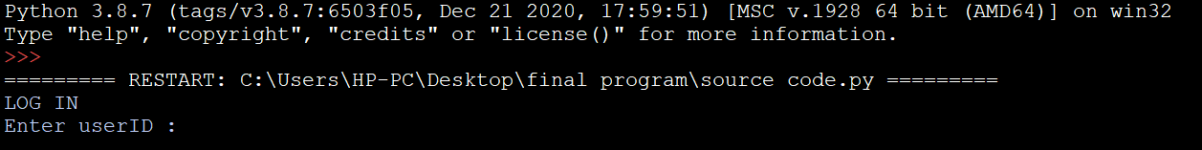

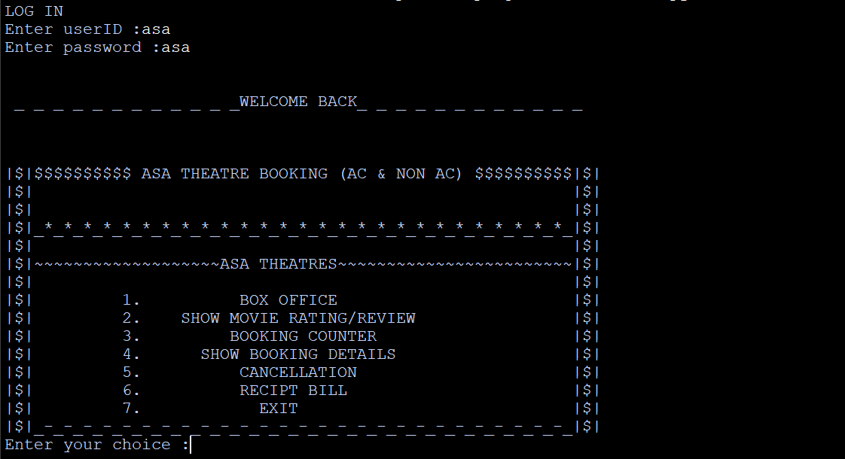

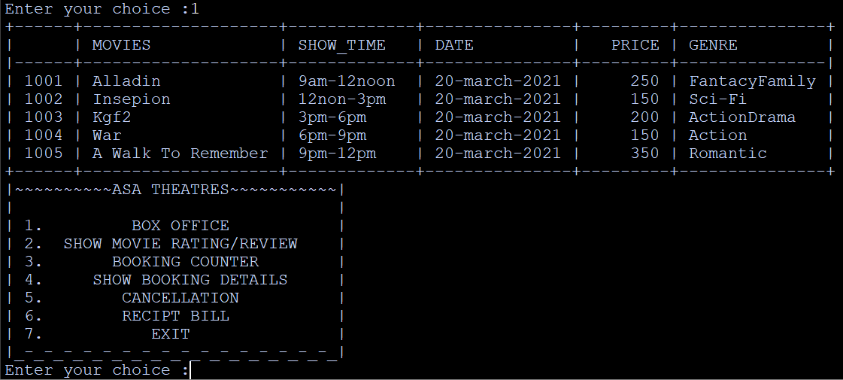

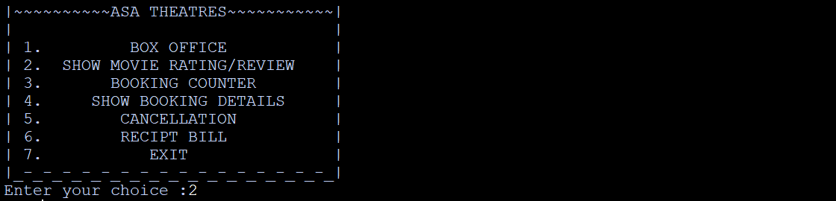

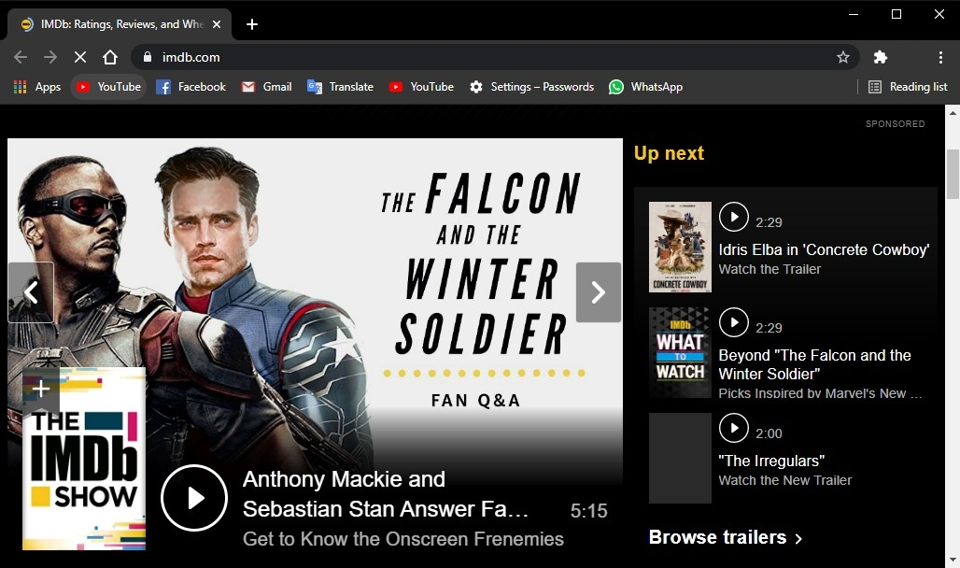

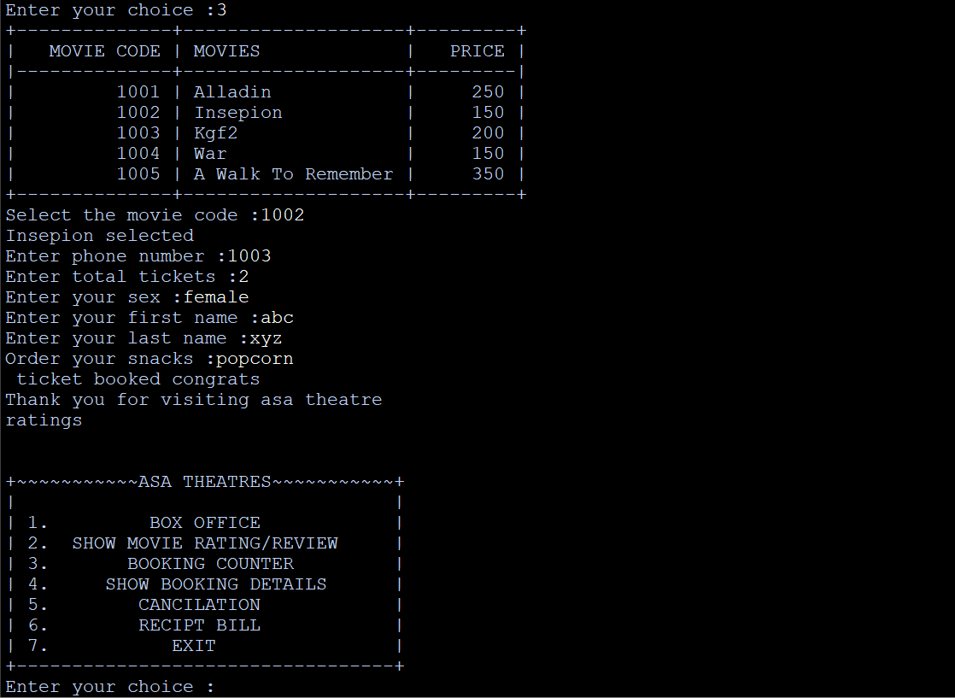

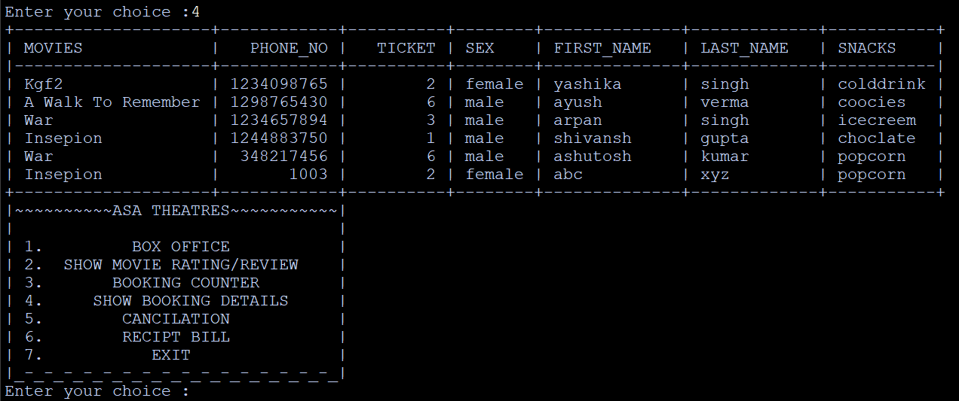

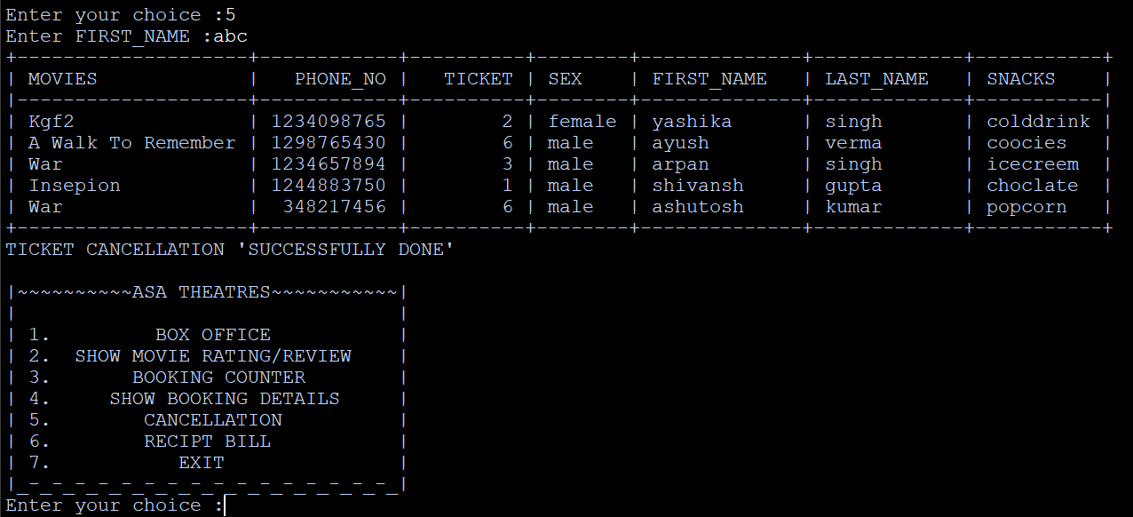

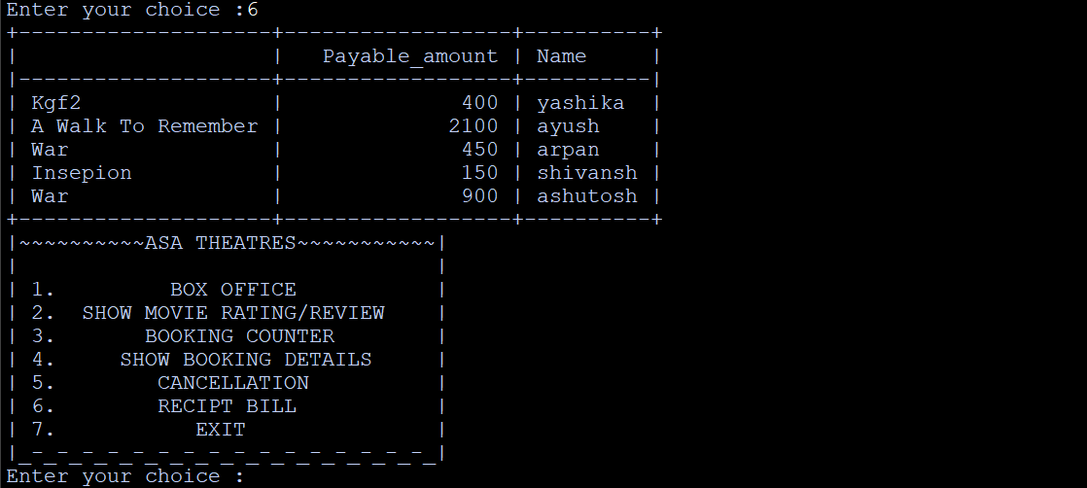

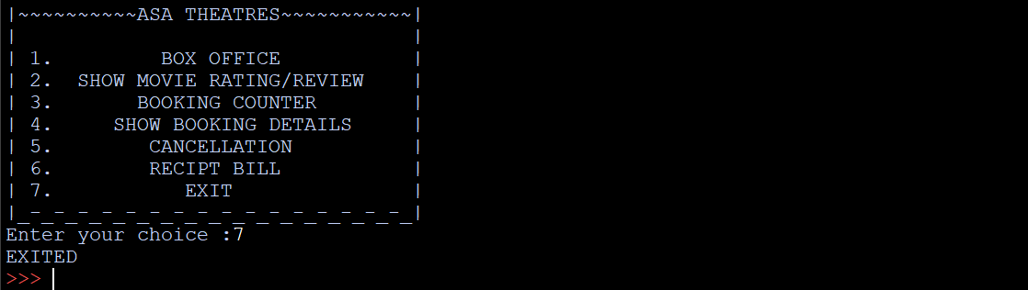

**BIBLIOGRAPHY**

1.Computer Science with python – Class XII

-By : SUMITA ARORA

2. WEBSITE :

* <https://www.geeksforgeeks.org>
* <https://www.google.co.in>
* <https://en.m.wikipedia.org>
* <https://github.com>
* <https://www.mysqltutorial.org>